DevOps Task – Day 3
GIT – init, add, commit, remote, push, branch, switch, pull and log
Field | Details
Name | Chandru
Date | 08-10-2026
Batch | 14
Topic | Day 3 – Git init, add, commit, push, set-url, branch, switch, pull

1. git init – Create a Local Repository
git init initialises an empty Git repository in the local folder. First we create the local repository, and then connect it to the remote repository.
git init
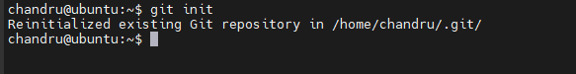
git init output
Note: Always run git init inside a project folder (for example ~/Devops_CL_B14). Never run it in the home folder (/home/chandru), or Git will track every file in home, including the private SSH key.
Create some sample files, for example:
touch file1 file2 file3

2. git add – Move Files to the Staging Area
After creating or changing files, add them to the staging area.
Command | Action
git add file1 | Add one file
git add file1 file2 file3 | Add multiple files
git add -A | Add all files (whole repository)
git add . | Add all files in the present working directory

3. git commit – Save a Snapshot
A commit can be thought of as a pointer, snapshot or milestone along the timeline of a Git project.
git commit -m "first commit"
-m adds the commit message. Write a short message about the change inside the double quotes.

4. Add the Remote Repository
After committing, connect the local repository to the remote (GitHub) repository so the changes can be pushed.
git remote add origin <Remote_SSH_URL>

Find the remote SSH URL
- Go to your GitHub repository.
- Click the drop-down on the Code button.
- Click SSH.
- Copy the SSH URL.
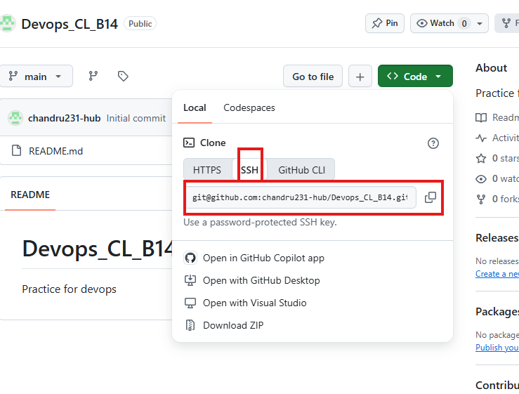
Code → SSH → copy the SSH URL
git remote add origin git@github.com:chandru231-hub/Devops_CL_B14.git

Change an existing remote URL
If origin is already added (for example with an HTTPS URL), change it to the SSH URL:
git remote set-url origin <SSH_URL_from_GitHub>
git remote set-url origin git@github.com:chandru231-hub/Devops_CL_B14.git
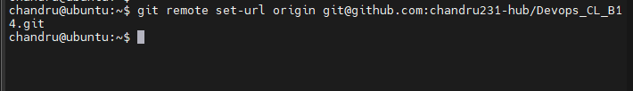
Setting the remote URL to SSH
git remote -v
Shows the remote URL the repository is connected to.

5. git push – Send Changes to GitHub
git push sends the commits from the local repository to the remote repository.
git push -u origin <branch_name>
git push -u origin main
-u links the local branch to the remote branch, so next time a plain git push is enough. Use master instead of main only if your branch is called master (check with git branch).

Common push errors and fixes
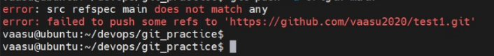
Error: src refspec main does not match any
Cause: nothing has been committed yet, or the branch is not called main. Fix:
git add .
git commit -m "first commit"
git branch -M main
git push -u origin main
Error: Support for password authentication was removed
Cause: the remote uses an HTTPS URL, and GitHub no longer accepts account passwords. Fix: switch the remote to the SSH URL and push again:
git remote set-url origin git@github.com:<username>/<repo>.git
git push -u origin main

6. Branches
A branch is a way to isolate development work on a particular part of a project – a separate stream of work.
When a branch is created, it diverges from the primary branch. Developers can work on a new feature or bug fix without affecting the main codebase.
Command | Action
git branch <branch_name> | Create a branch (e.g. git branch devopb13)
git checkout -b <branch_name> | Create a branch and switch to it (e.g. git checkout -b devopsb102)
git switch <branch_name> | Switch to another branch (e.g. git switch testing)
git branch | List the local branches

Example output of git branch:
git branch
devopsb11
* master
The * marks the current branch.

7. git status
git status shows the current state of the working directory compared with the local repository – which files are new, changed, staged, or already committed.
git status

8. git pull – Get Changes from GitHub
git pull downloads the changes from the remote repository and updates the local repository – for example, changes made to a branch by team mates.
git pull origin <branch_name>
git pull origin main
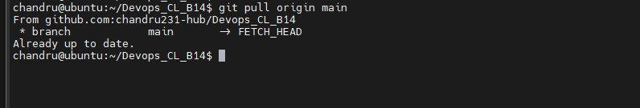
git pull origin main – already up to date

9. git log – Commit History
git log shows the history of commits.
git log
git log --oneline
Example:
1729f82 (HEAD -> master, origin/master, feature, devopsb10, dev) Adding a file
- 1729f82 – the commit hash (short ID of the commit)
- HEAD -> master – the branch you are currently on
- origin/master – the same commit on GitHub (local and remote are in sync)
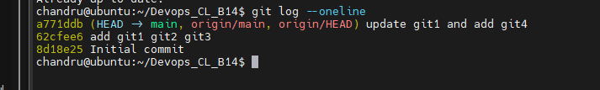
git log --oneline – latest commit at the top

10. Quick Reference – Daily Workflow
Command | Purpose
git status | Check what changed
git add . | Stage the changes
git commit -m "message" | Save a snapshot
git pull origin main | Get team mates' changes
git push origin main | Send to GitHub
git log --oneline | View history

